**Lab – 27: See a recommendation prompt for labeling and automatic protection.**

**Objective:** The objective of this lab is –

* To see a recommendation prompt for labeling and automatic protection.

In this lab, you are going to see a recommendation prompt for labeling and automatic protection.

**Prerequisite:** EMS Enterprise Mobility + Security E5.

**Steps:**

1. In the Word document, type a valid credit card number, for example: 4242-4242-4242-4242.
2. Save the document locally, with any file name.
3. While saving, you’ll be prompted to select the label for this document. So, you need to select label. Here, select **Confidential \ Educational** that you have configured. Click **OK**.

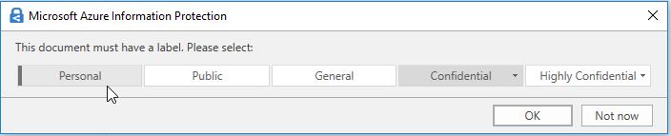

1. Then save the document. And, see the sensitivity level is: **Confidential \ All Employees.**
2. You immediately see the watermark of your organization name across the page, the header of **Classified as Confidential** and the footer of **Microsoft** is also applied. The document is also protected with the permissions that you specified for this label.
3. So, in this way, you see a recommendation prompt every time (when you have not applied) for labeling and automatic protection.

